Project design
Class diagram
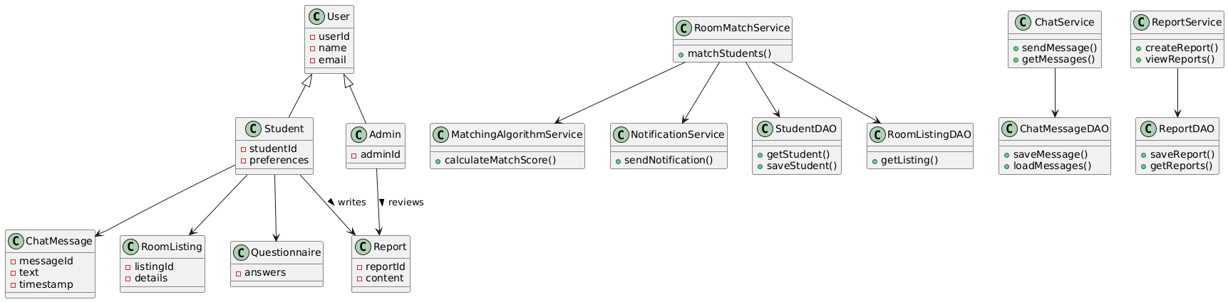

Sequence diagram
